DATE:__________NAME:__________________________SEX:_______AGE:_______
PLEASE COMPLETE FOLLOWING 2 PAGE MEDICAL QUESTIONNAIRE REGARDING YOUR CONDITION AND MEDICAL HISTORY. THANK YOU.

R or L handed ? Occupation:_________________Sports/Activities:_________________

Please mark on the diagram below the main (ie. only one please) area where you are experiencing symptoms and please describe the symptoms with the letter codes below:

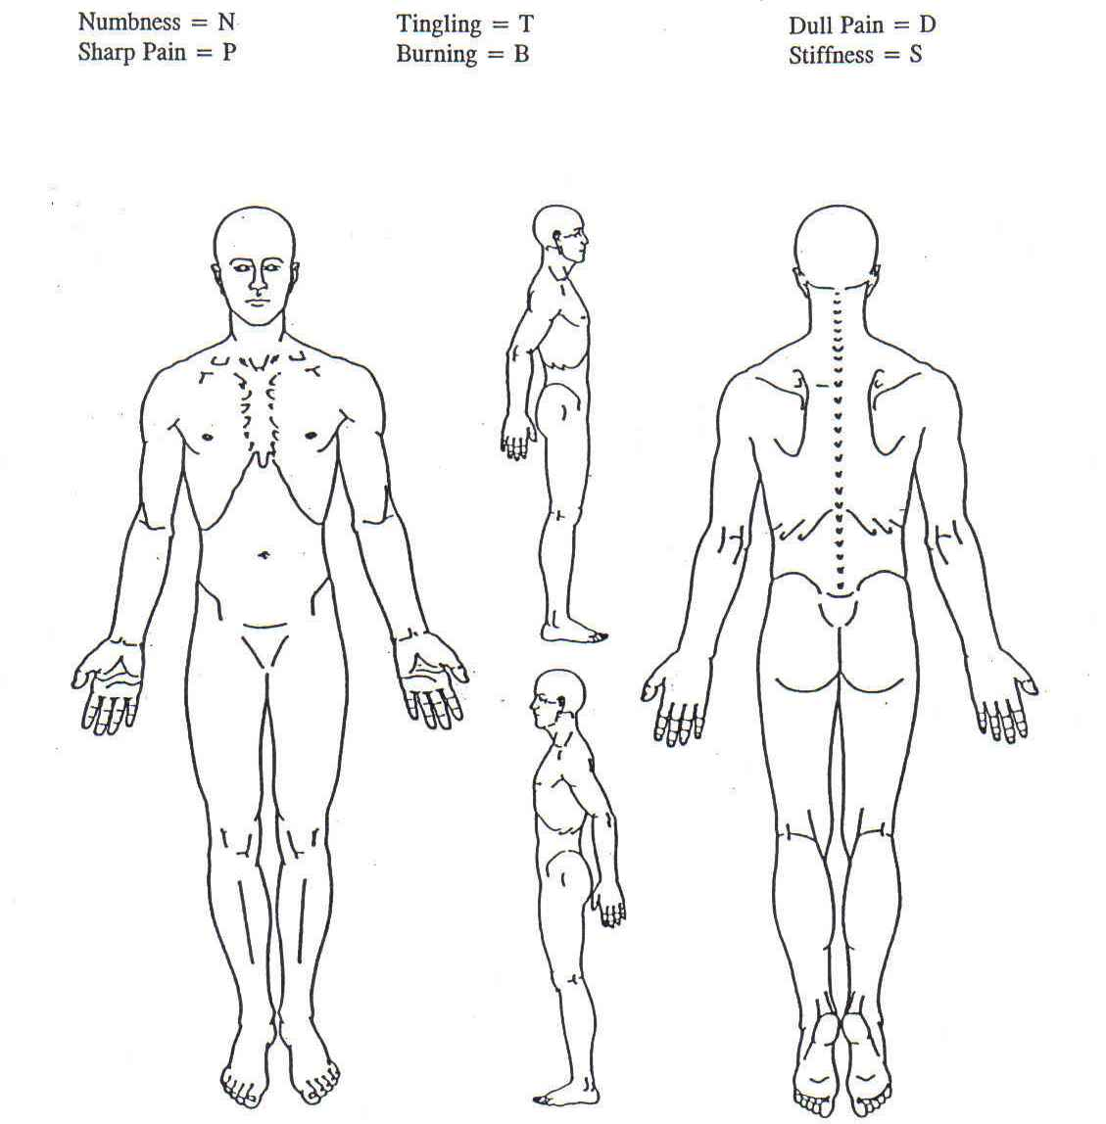
How long have you had this condition?

If there was an injury, please describe mechanism:

If there was no injury, how do you think your condition developed?

Please list any associated symptoms if any (eg. Weakness, swelling, loss of function, etc.)

Please list movements, activities, factors that makes your condition worse:

Please list anything that makes your condition feel better:

Please list all investigations/tests/imaging you have had for your condition, when it was done and indicate the results of each if known:
Name:_______________________________ Date:___________________

Please list all treatments/therapies/medications/procedures that you have tried for your condition. Please indicate how many times/how long you tried each, when this took place, and the percentage improvement if any from each:

Please list the medical/health care practitioners you have seen re. your condition and what did they indicate the diagnosis (if any) and recommendation(s) (if any).

Please list ALL present and/or past medical condition(s), serious injuries, surgeries, hospitalizations etc. you may currently or have had previously in your life:

Please list ALL medications and supplements you are currently taking:

Please list any medications or medical devices (eg. Latex, tape) you are allergic to:

Please list any past/present psychiatric history and/or history of alcohol/chemical/ substance dependency (please specify what substance):

If female, are you currently or planning to become pregnant or breast feeding ? Y or N

Signature: ______________________________ Date:_____________

